Manual
for SHS-CO2-2K CO₂ Module

Thank you for choosing this product.

Please read the manual carefully before you use this product, and operate seriously in its suggested way. Keep this manual, you may need its help in the future.

© Copyright statement

Any part of this manual can not be copied, translated, stored or distributed in any database or retrieval system without written permission from us by any means and ways, including electronic, copying and recording.

We concentrates on its product improvement with the help of innovation in science and technology continuously.

We keeps the right to improve the product without any notice.

If users disassemble or replace any part of the product not in the way suggested in this manual, the risks must be taken by the users themselves.

More details of the products, including the color and style, depend on the product you get.

Contents

1． Introduction 1
2． Technical Data 1
3． Dimensions 2
4． Signal Output 3
5． Installation instructions 4
6． Maintenance and storage 5
7． How to place order 5

- Introduction
SHS-CO2-2K is one of the general NDIR CO₂ gas modules, which adopting NDIR principle, consists of advanced light chamber, precise electric circuit and intelligent software. With the help of single light source, single channel detector, and microprocessor, SHS-CO2-2K can perform the gas concentration signal in different ways. In this product, temperature compensation has been realized as well as the revision of the nonlinear relationship. SHS-CO2-2K has the function of self calibration in every 24 hours. It has all the advantages from NDIR products, such as good selectivity，high sensitivity, long life and independence to O_{2.}
SHS-CO2-2K is suitable for the test in flexible occasion, for example indoor air monitoring, ventilating system, cars etc.
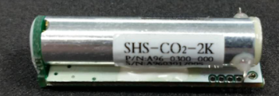

- Technical Data
2.1 Working conditions
Description | Symbol | Value | Unit
Storage temperature | T_{stg} | -20 to +70 | °C
Working temperature | T_{A} | -10 to +60 | °C
Working humidity | H_{A} | 0 to 95 (no condensation) | % RH
Working voltage | V_{DC} | 5±0.5 | V
Working current | I_{average} | 40 | mA
Working current | Ipeak | 140 | mA

2.2 Performance characteristics
Description |  | Parameter | Unit
Working principle |  | NDIR
Detection range |  | 0-2000 | ppm
Detection accuracy |  | ±50ppm±5% reading
Response time T₉₀ |  | ＜3 | minute
Warm-up time | Set to work | ＜60 | second
Warm-up time | precision reached | ＜15 | minute
- Dimensions

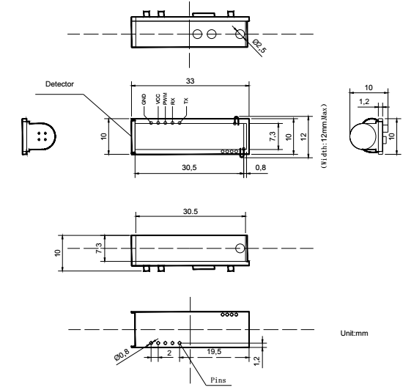
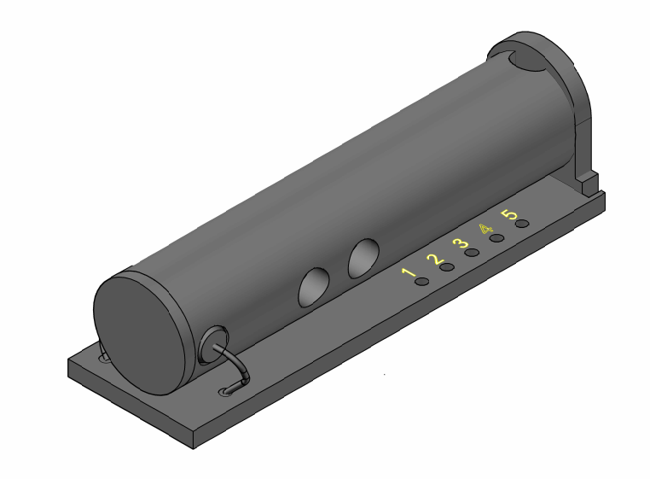
- Signal Output
Output Mode: UART, PWM
Interface Definition:
Pin Number | Function
1 | TTL TXD
2 | TTL RXD
3 | PWM Output
4 | +5 VCC
5 | GND

  - UART Protocol
Baud rate：19200bps，8 bytes，first byte is stop，no check byte. The reading and return data is hexadecimal.
Concentration uploaded automatically in ASCII with the format :

32 | 32 | x | x | x | x | x | 32 | p | p | m | \r | \n

For example：output of 12345 ppm：
 |  | 1 | 2 | 3 | 4 | 5 |  | p | p | m
0x20, 0x20, 0x31, 0x32, 0x33, 0x34, 0x35, 0x20, 0x70, 0x70, 0x6d,

  - PWM Output
PIN 3 is the PWM output，definition is:
Concentration range： 0-2000ppm CO2
Cycle: 1004 ms ±5%
How to calculate the positive pulse width of PWM based on the CO2 concentration:
The positive pulse width = (PPM concentration / 2)+2ms
1004ms
2ms
4ms

0ppm
2ms
4ms
5ms

5ms
252ms

999ms
1002ms

2ms

4ppm
6ppm
500ppm
1994ppm
2000ppm
1004ms
PWM OUTPUT
- Installation instructions
The distance between the installation holes is 2 mm.
Connect the module with a client through the single-row socket with distance of 2 mm.

6． Maintenance and storage
The module cannot work in dusty environment for a long time. Supply power should be in its proper range.

7． How to place order

In order to get the product you want, please specify the following information when place your order:
1） Model of the module.
2）Measuring Range and detection accuracy of the module.
For example:
SHS-CO2-2K 0-2000ppm ±50ppm±5% reading

